Vishal Patel, Karandeep Chana, Matthew Strudwick

University of Brighton

Game Report

CI328 – Assessment 2, Game Design and Implementation

**Game Summary**

Overview

Our game is called ‘The Hunting’. It’s a game of the action genre. It’s a network multiplayer game where each player controls a spaceship. The spaceship is able to fire laser bullets. The main aim of the game is to eliminate enemy spaceships until one spaceship remains. The player who controls that spaceship wins. We used Adobe Flash Professional and SmartFoxServer to create our game.

Objectives

* Choose a spaceship from a selection of four.
* Control the multi-directional moving spaceship using Arrow keys.
* Destroy enemy players via a firing system using Spacebar key.
* Maintain your health bar above 0.
* Survive until you’re the last player remaining.

Rules

* You must select your spaceship before you start the game, once selected you cannot change until that round is over.
* The spaceship can be moved 360 degrees. However it can’t go off the bounds of the map.
* Laser bullet ammunition is unlimited, hence every player can fire an unlimited amount of laser bullets.
* A minimum of two players are required for the game to begin.
* Each round will end, either if one player is remaining having eliminated all other players, or if all players but one have left the game, thus leaving that last remaining player the winner.

Gameplay

A player is spawned in a random location on the map. They will have full health, three bars. Immediately they may or may not see enemies, they must navigate around the map looking for enemies. Once they find them, they will begin firing laser bullets to kill them. When a player is killed they’re faced with a game over screen asking them to either spectate the game or exit. If they spectate they will watch the remaining players. When the winning player kills the final opponent, they are faced with a game over screen as well. However the game over screen will have their score. The spectate button will become inactive.

**Screen/Level Map**

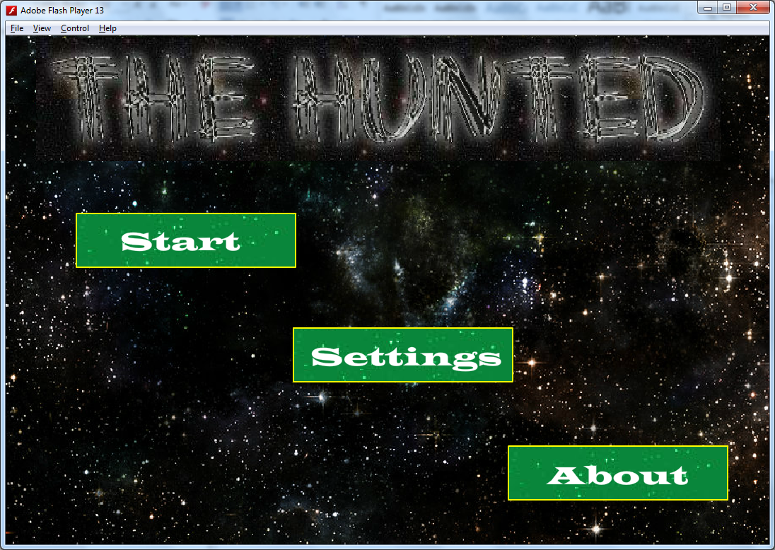

Buttons

Here is the first screen, which is shown, when the game is first started, The MenuScreen. Pressing any of the buttons directs to the respective screen.

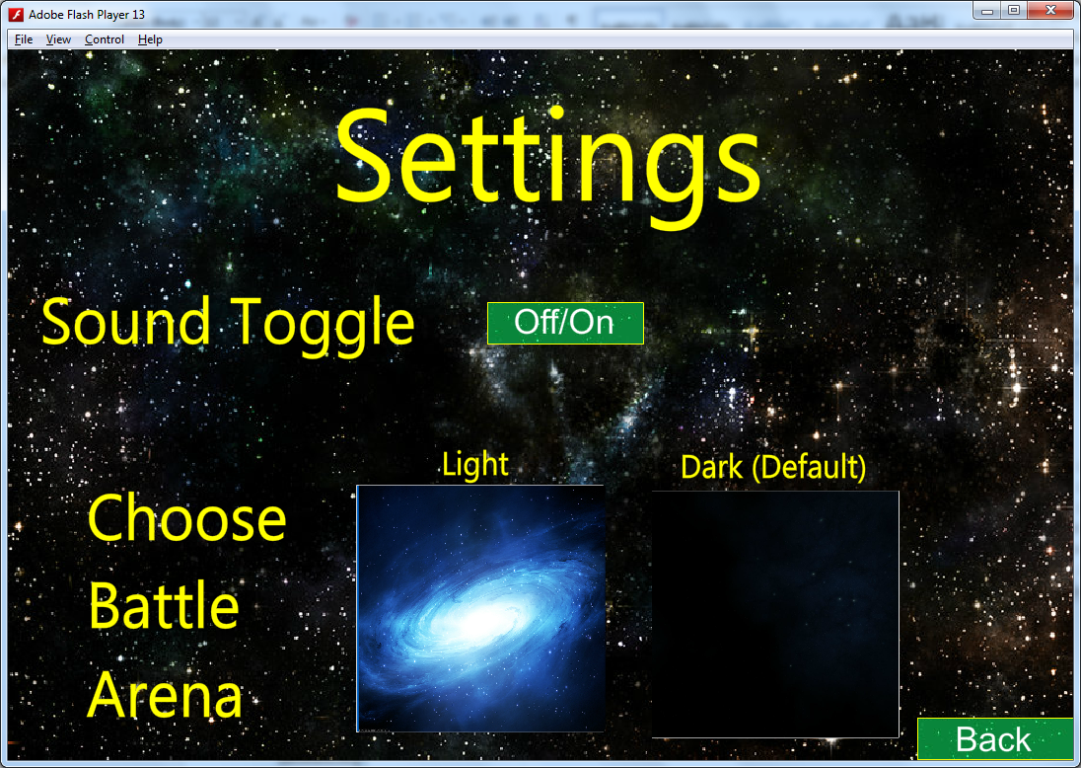

If the Settings button is pressed on the MenuScreen, the SettingsScreen is displayed. Here settings about the game can be altered. The Back button goes back to the MenuScreen.

If the About button is pressed on the MenuScreen, the AboutScreen is displayed. Here information about the game is displayed. The Back button goes back to the MenuScreen.

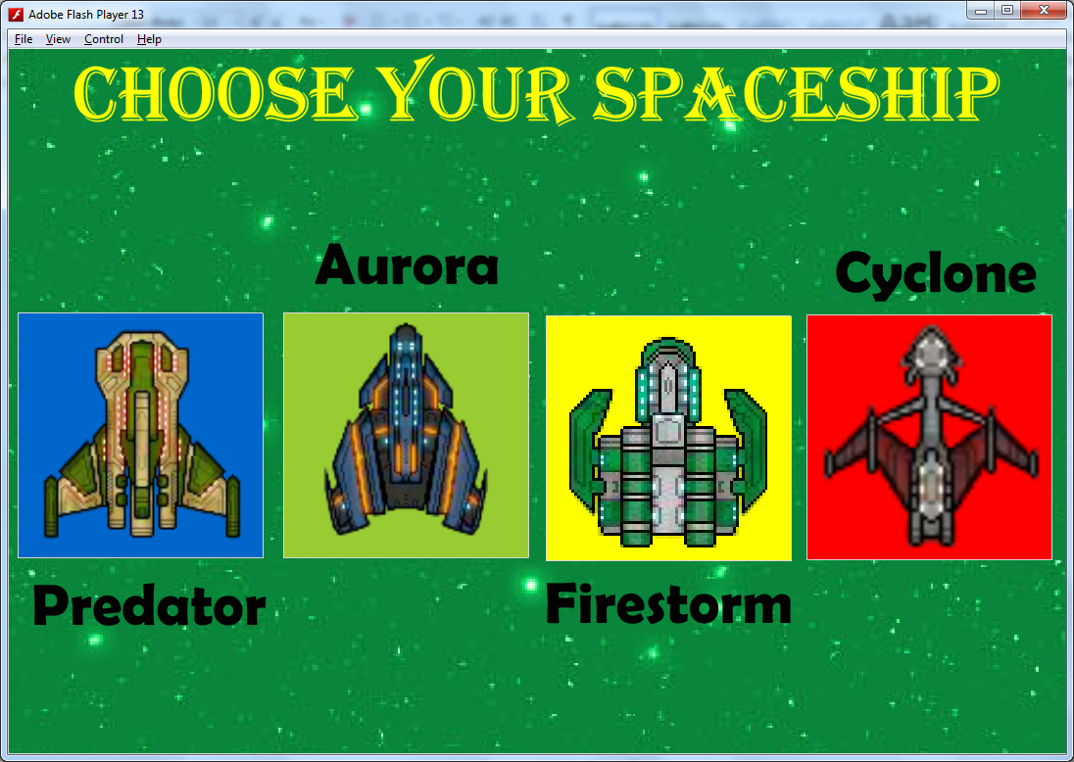

If the Start button is pressed on the MenuScreen, the SelectScreen is displayed. Here a choice of spaceships are displayed, from which one must be selected to start the game.

**Network Utilization**

Network Architecture

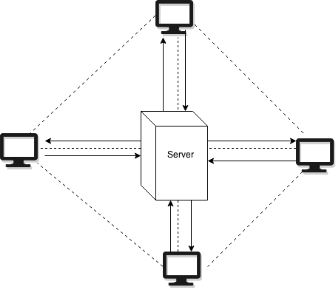

Component Interactions

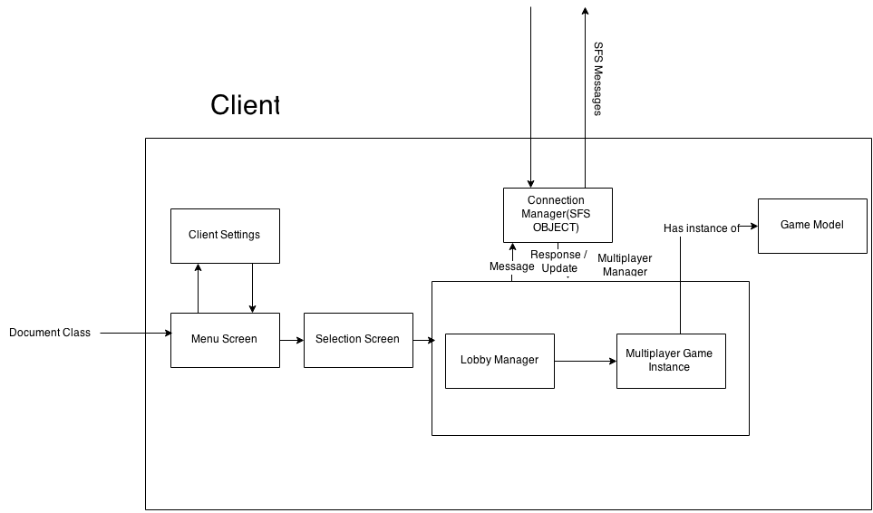

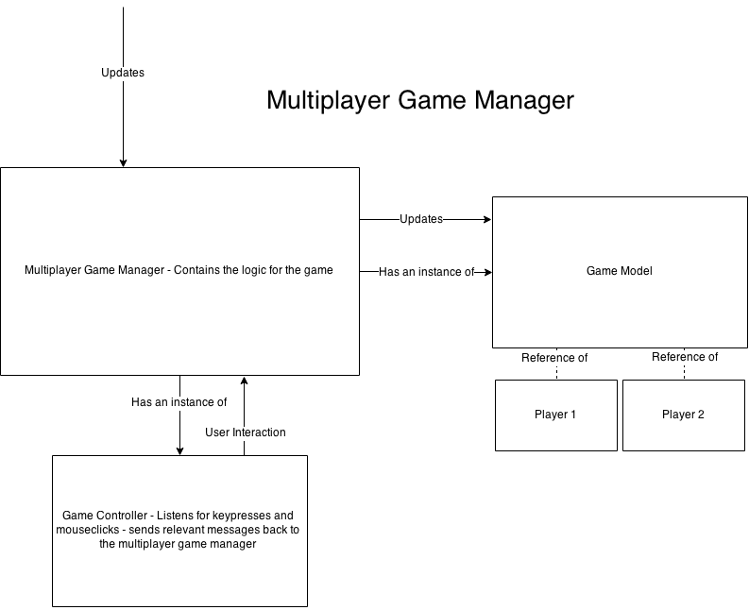

**Implementation Specification**

**Clients**

Objects

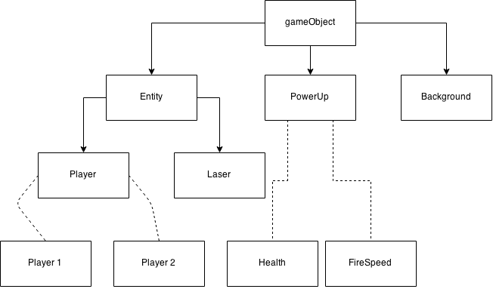

Code Structure

Assets

**Server**

Data Structures

Code Structure

**Implementation Evaluation**

**References**

Space-Star Background (Website) - <http://fantmayo.deviantart.com/art/Stars-Background-211786850>

Light Space Background (Website) - Reference - <http://wallpaper-kid.com/cool-space-background-blue.htm>

The Hunted Custom Font Title (Website) - <http://www.cooltext.com>

**Appendix 1:** **Game Concept Presentation**

**Appendix 2:** **Extra Information**